**Protocol for running 7 tesla MRI scanner**

**How to start:**

1. Turn the power gauge to ON.

1. Press standby and let it to turn into solid orange/yellow light
2. Then press ON button and wait until it turns into solid green.
3. Open “ParaVision 360” software from the desktop of “Bruker” computer.

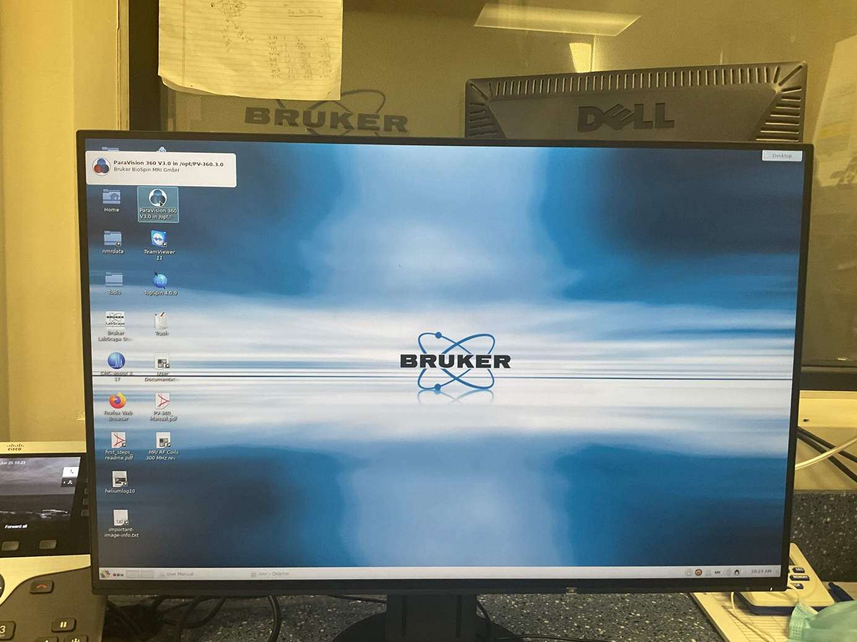

1. Allow the software to load up and DO NOT close any of the windows that automatically opens.

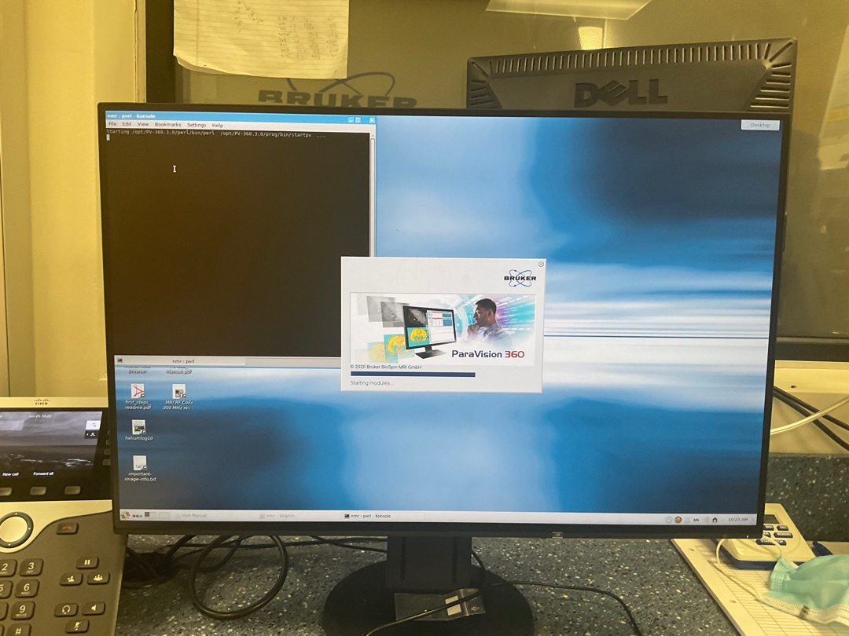

1. When the software is completely loaded, go **:**

* Files >> New >> Study

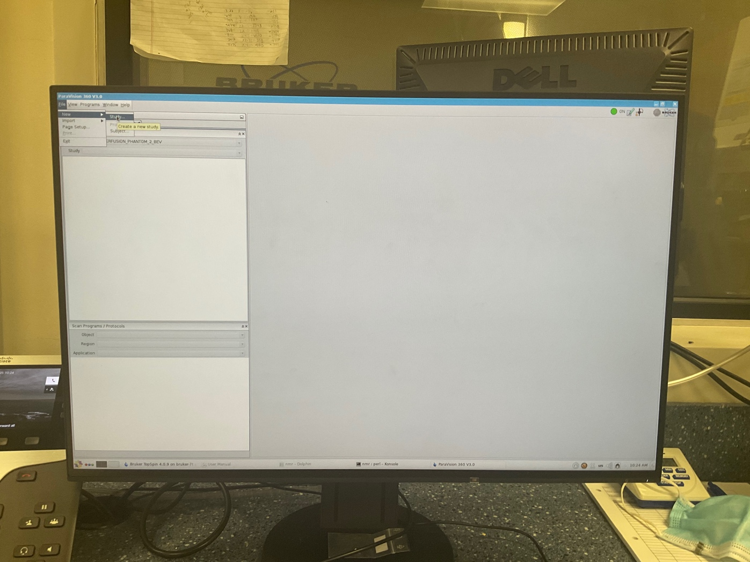

1. Fill the required tabs shown in **bold.**

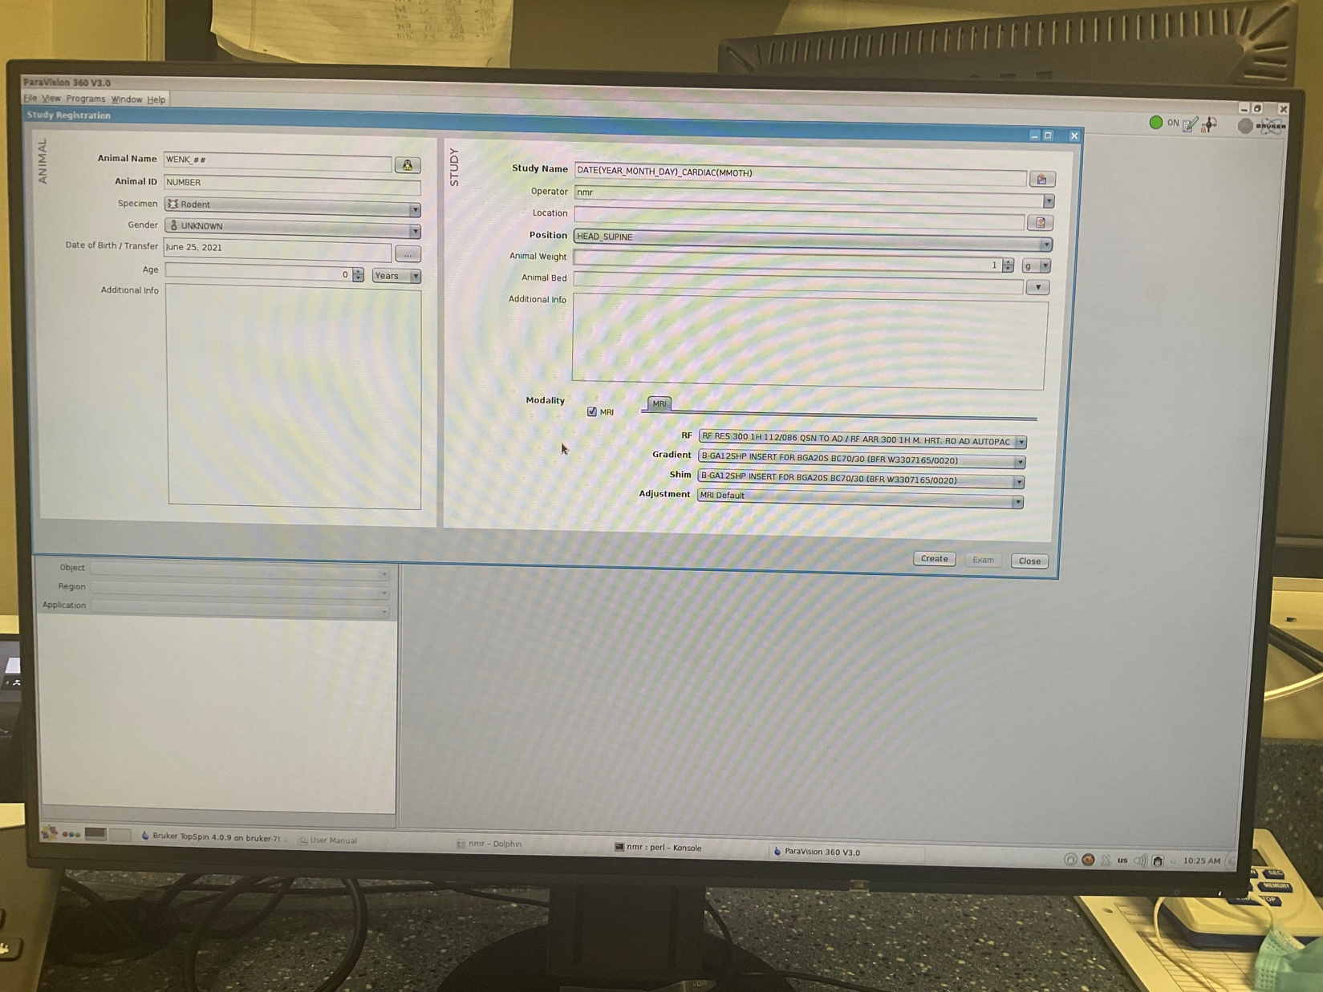

* **Animal Name:** WENK_##
* **Animal ID:** Animal_muber
* **Study Name:** WENK_DATE(YY_MM_DD)_CARDIAC(MMOTH)
* **Position:** HEAD_SUPINE

1. From “Scan Program / Protocols” tab on the left hand side, select **user** protocol

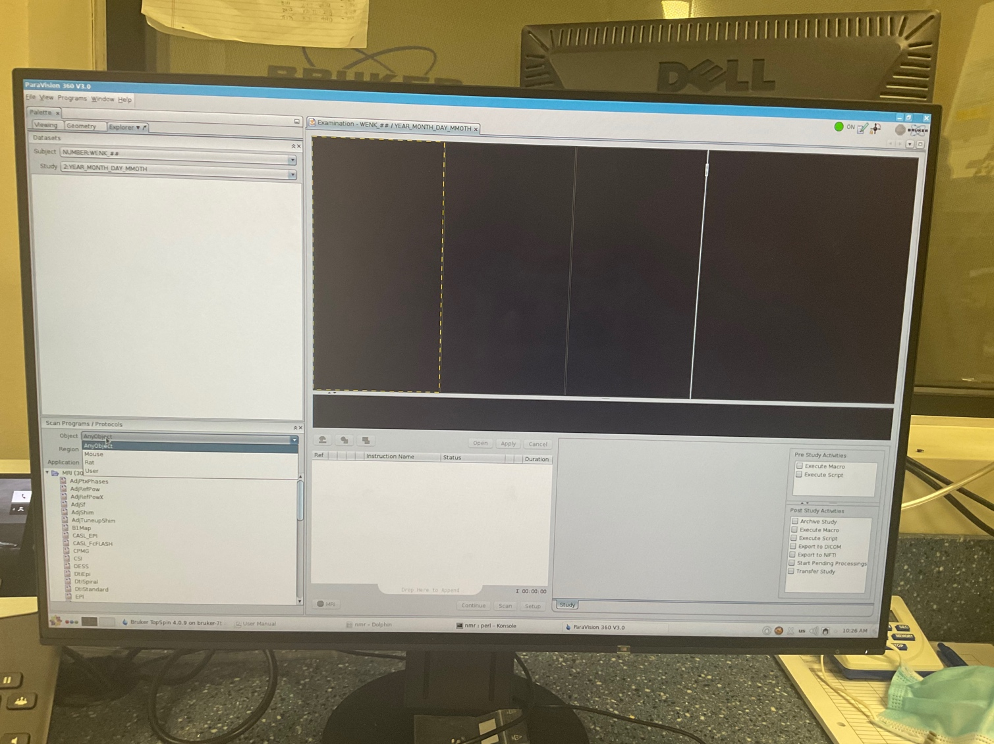

1. Select “Region”, it should be user-defined protocol for this specific srufy.
2. Select “Heart” for “Application”.
3. Select the first protocol step from the left_down panel and drag it to middle_down panel.

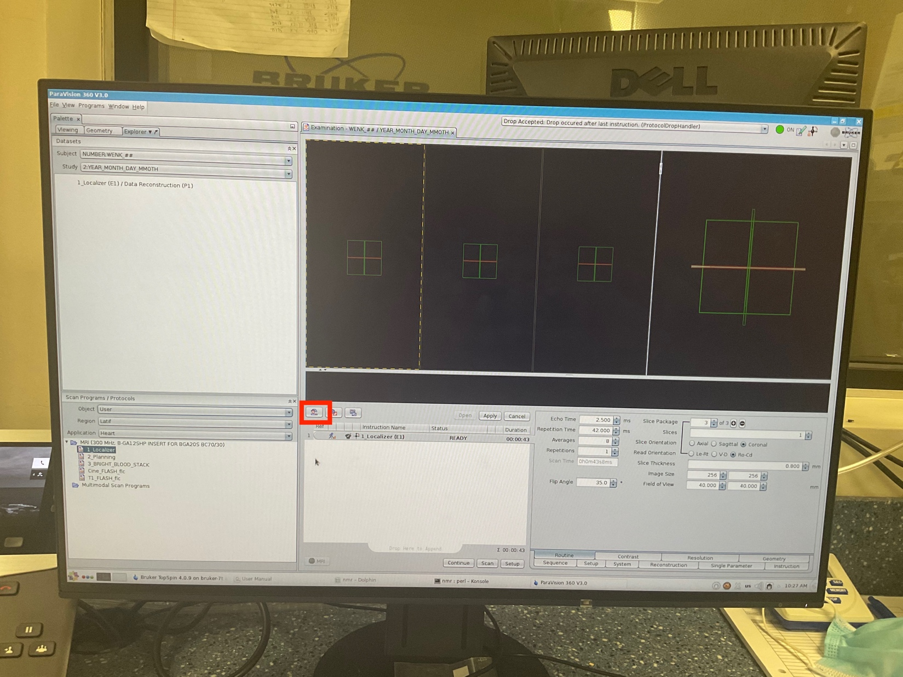

1. Then click on the enclosed icon to open the menu for adjusting the “**wobble**”.

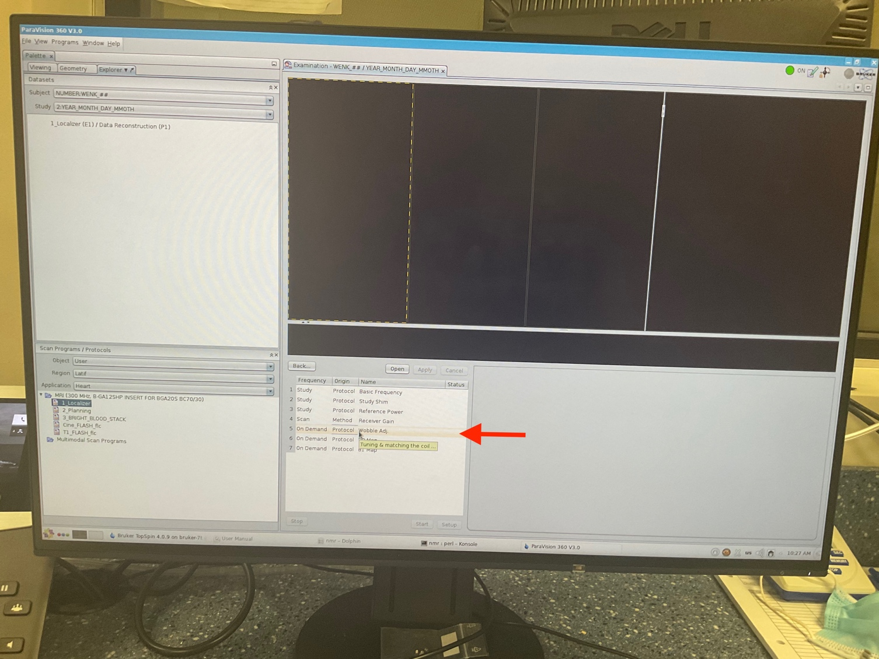

1. Select “Wobble adjustment” shown with the red arrow.

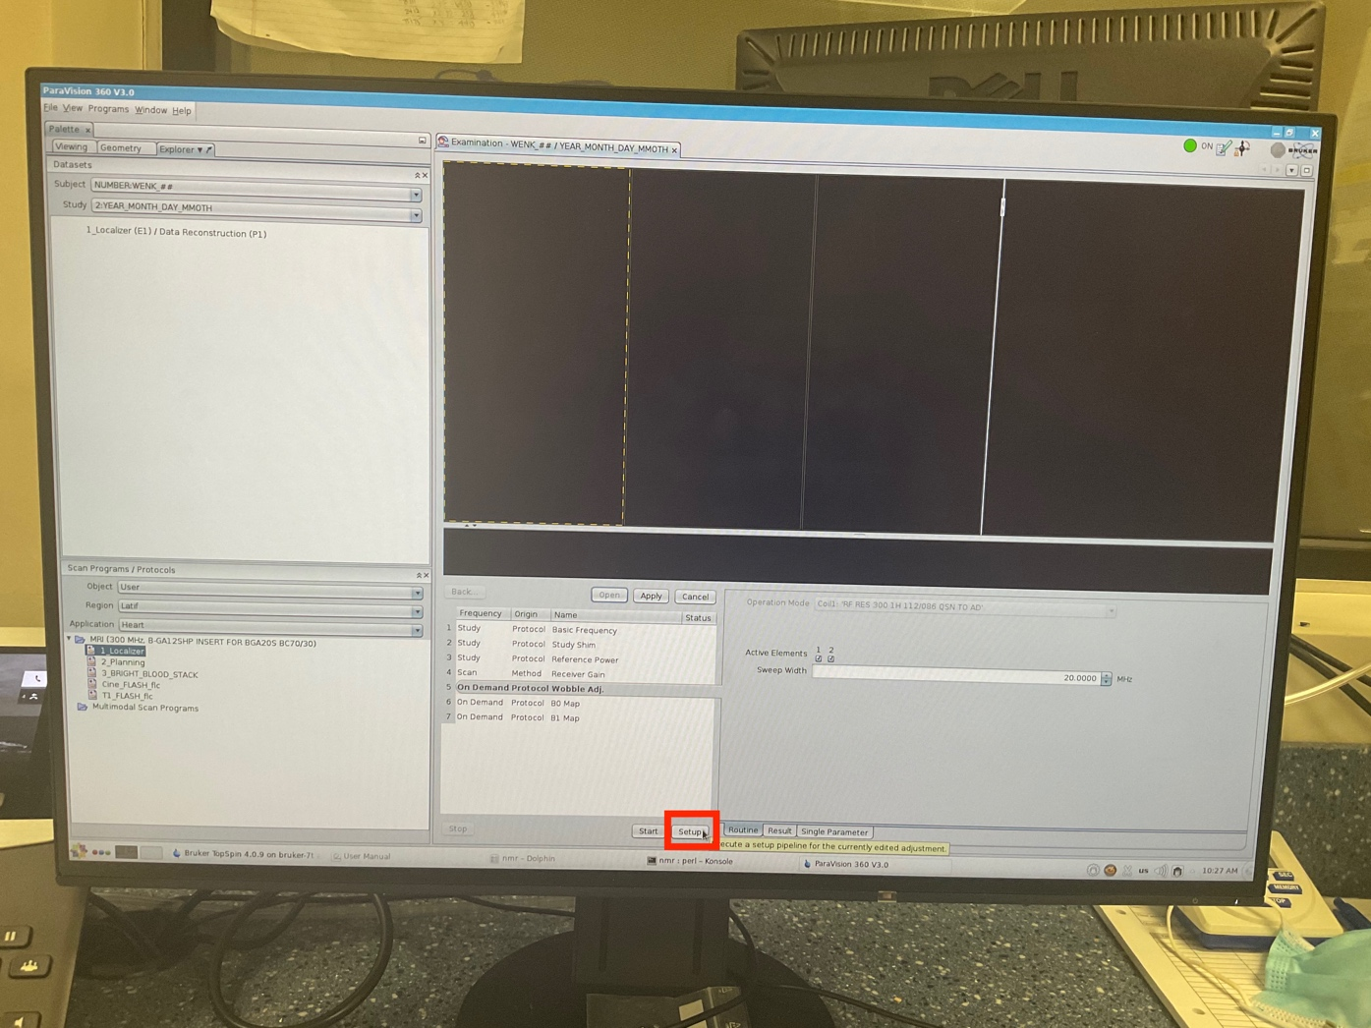

1. Click on “Setup” button to adjust the wobble setting.

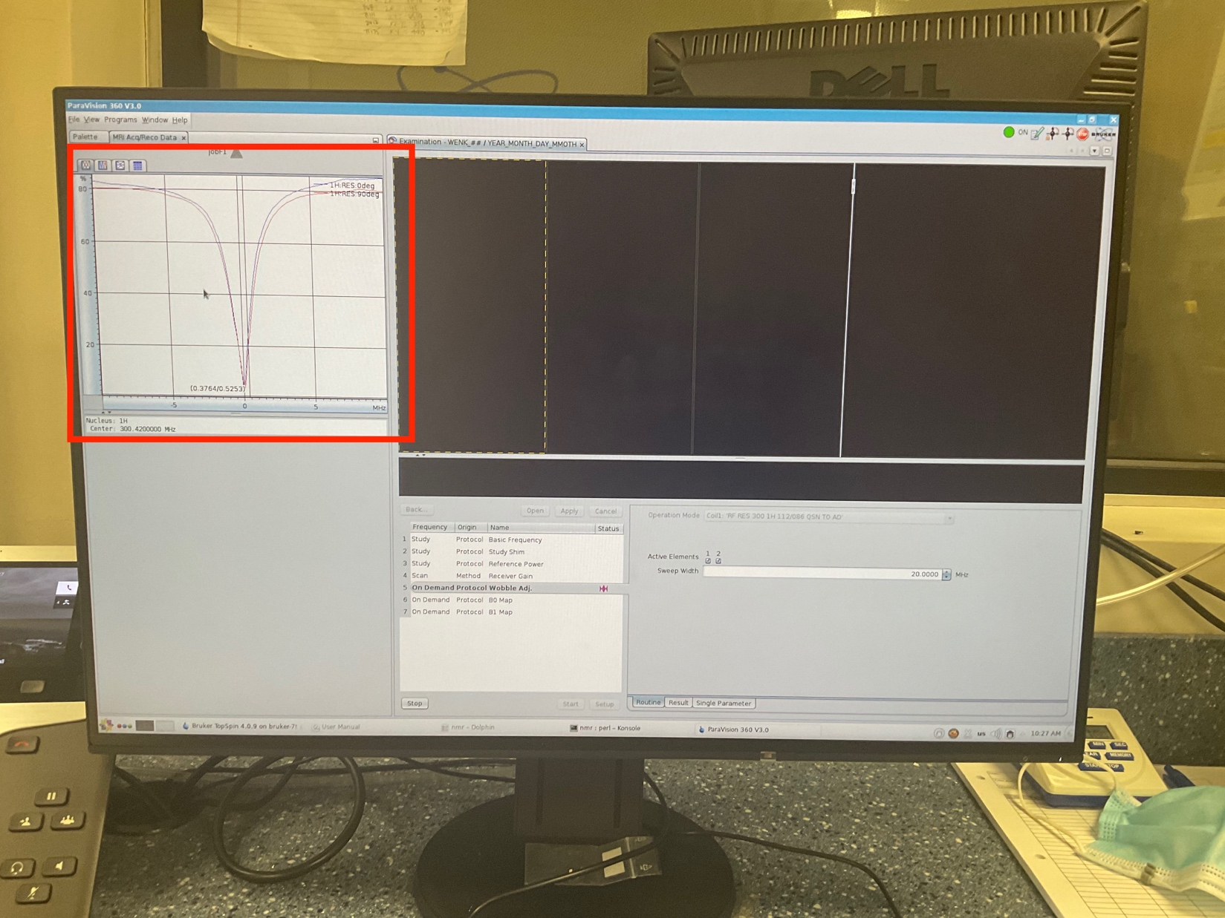

1. Then, the user must go into the scanner room at the behind of the scanner to manually adjust the wobble.
2. The adjustment should be done in a way that:
3. The vertical line would be placed at the center of two diagrams
4. The amplitude of diagrams is deep enough to touch the minimum horizontal line/ axis.

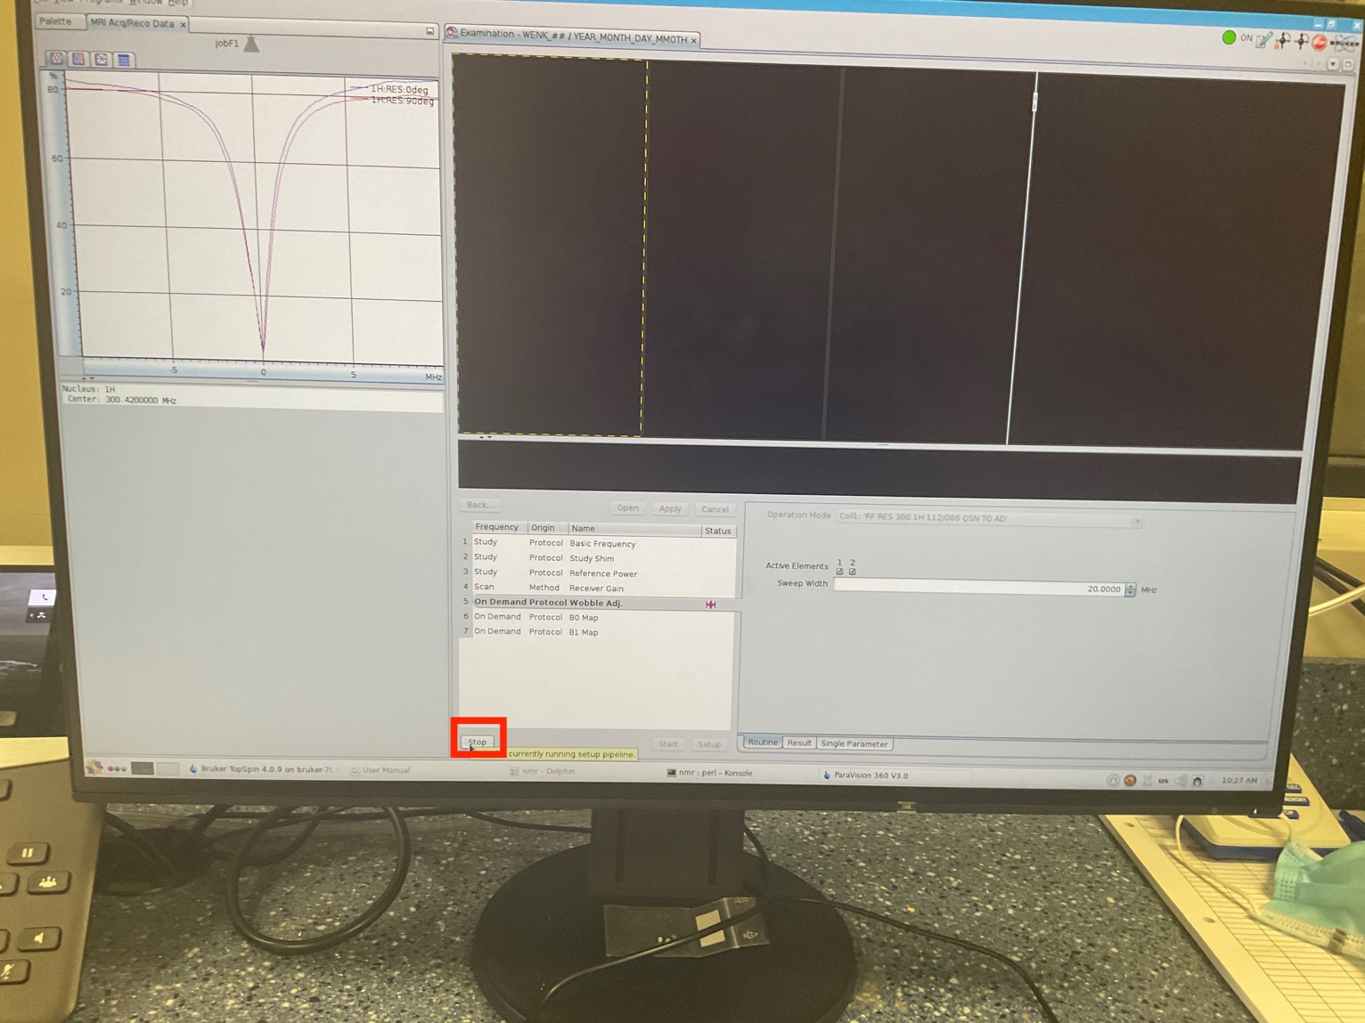

1. Then on the software screen, hit the “stop” button.

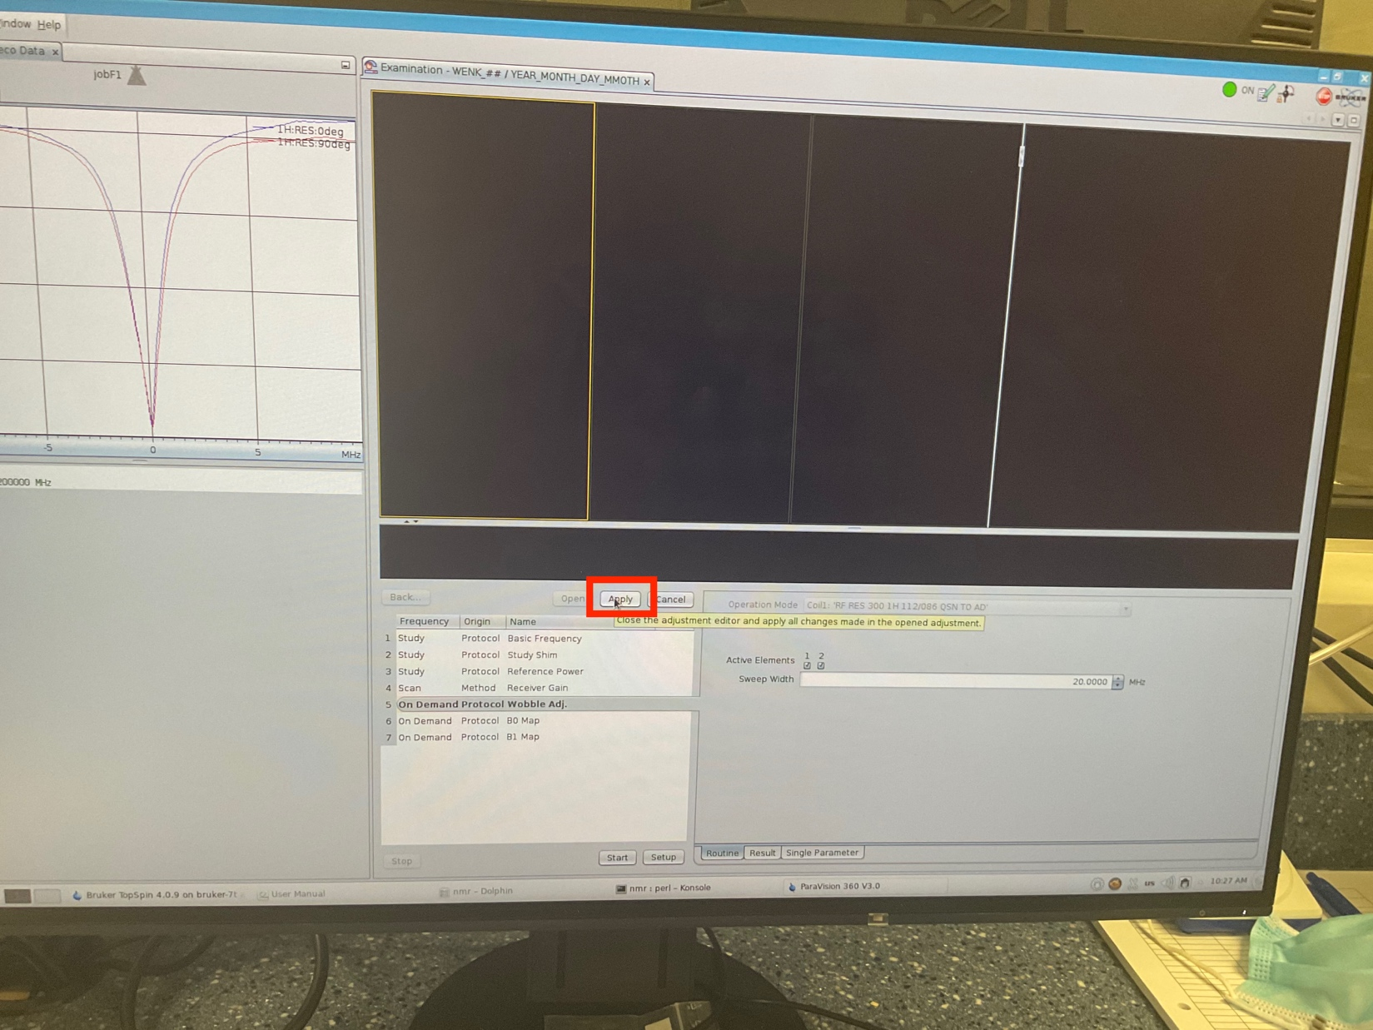

1. Then “Apply” the changes.

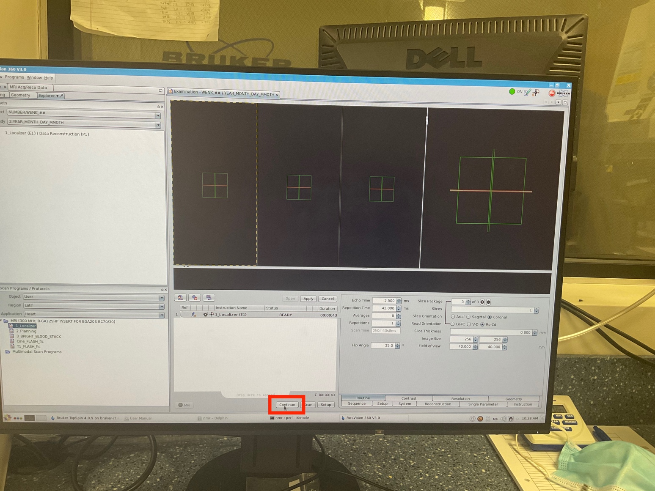

1. Click on continue to allow the scanner to start scanning.

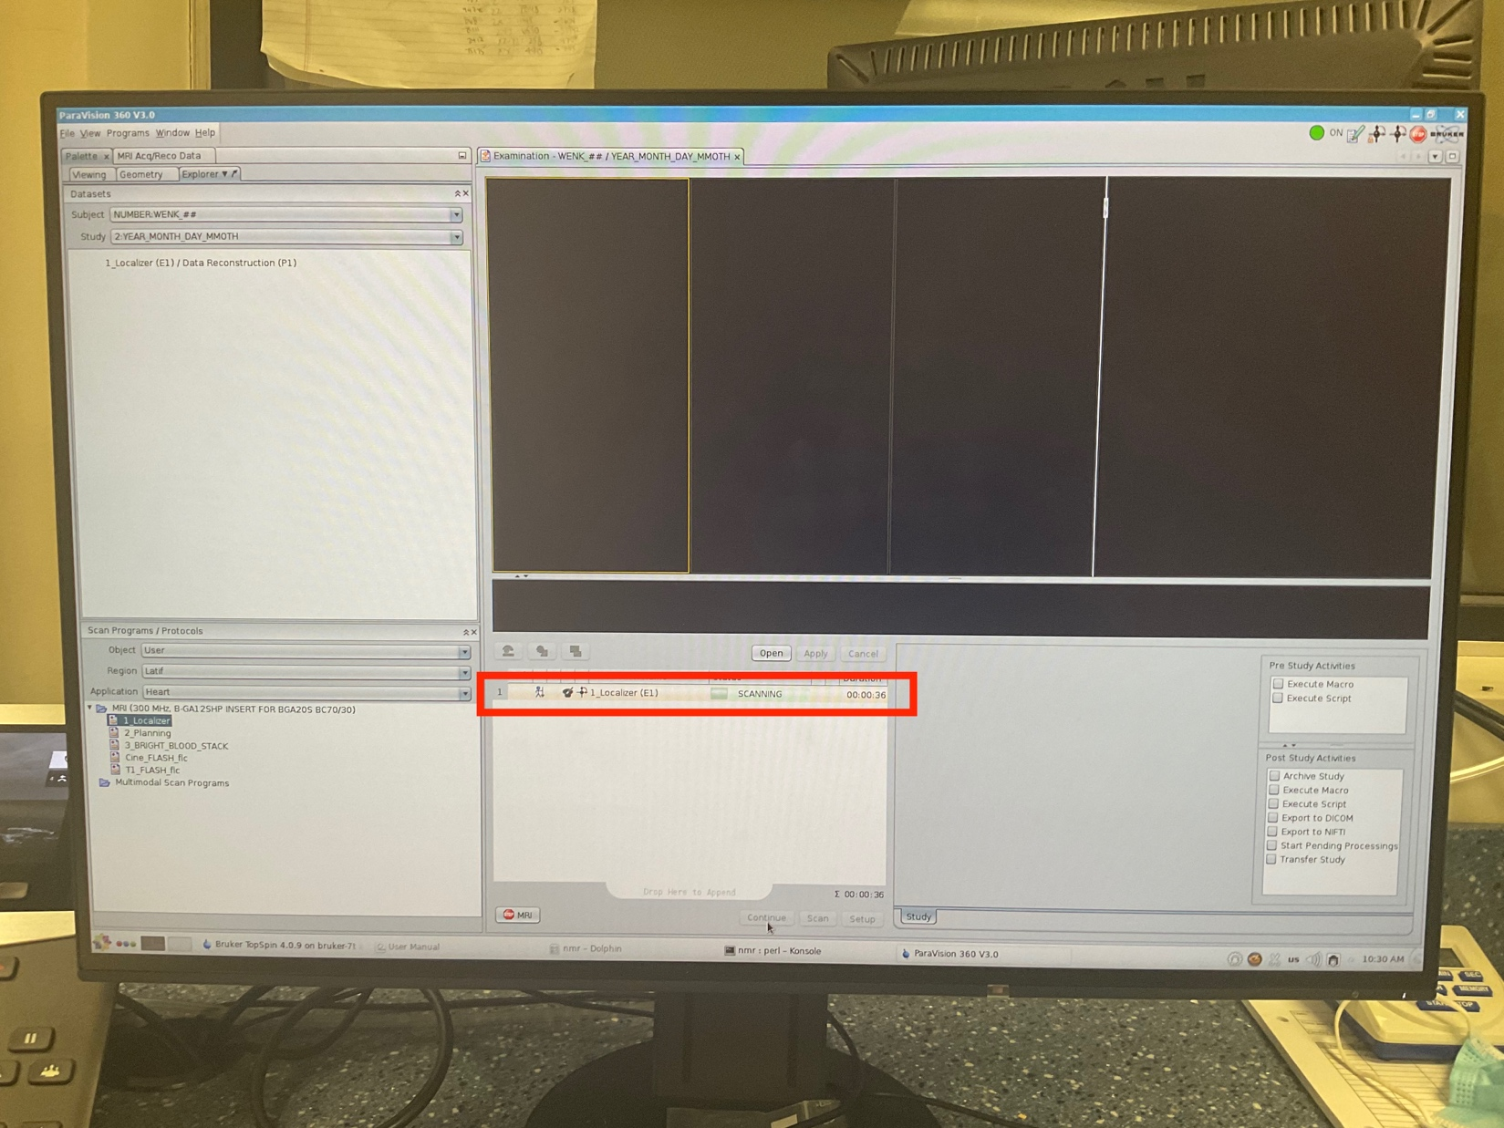

1. Allow the scan to be completed. It usually takes couple minutes.

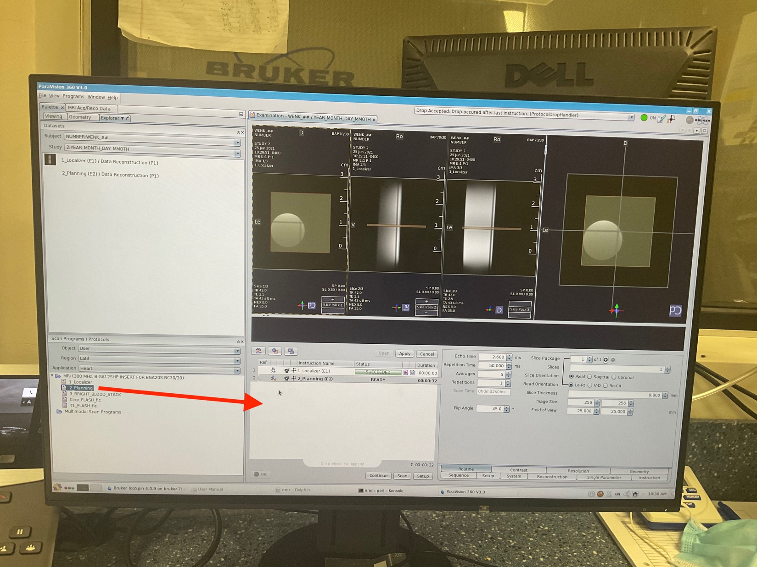

1. When the first step is finished, drag the next step to the middle “operating” window.

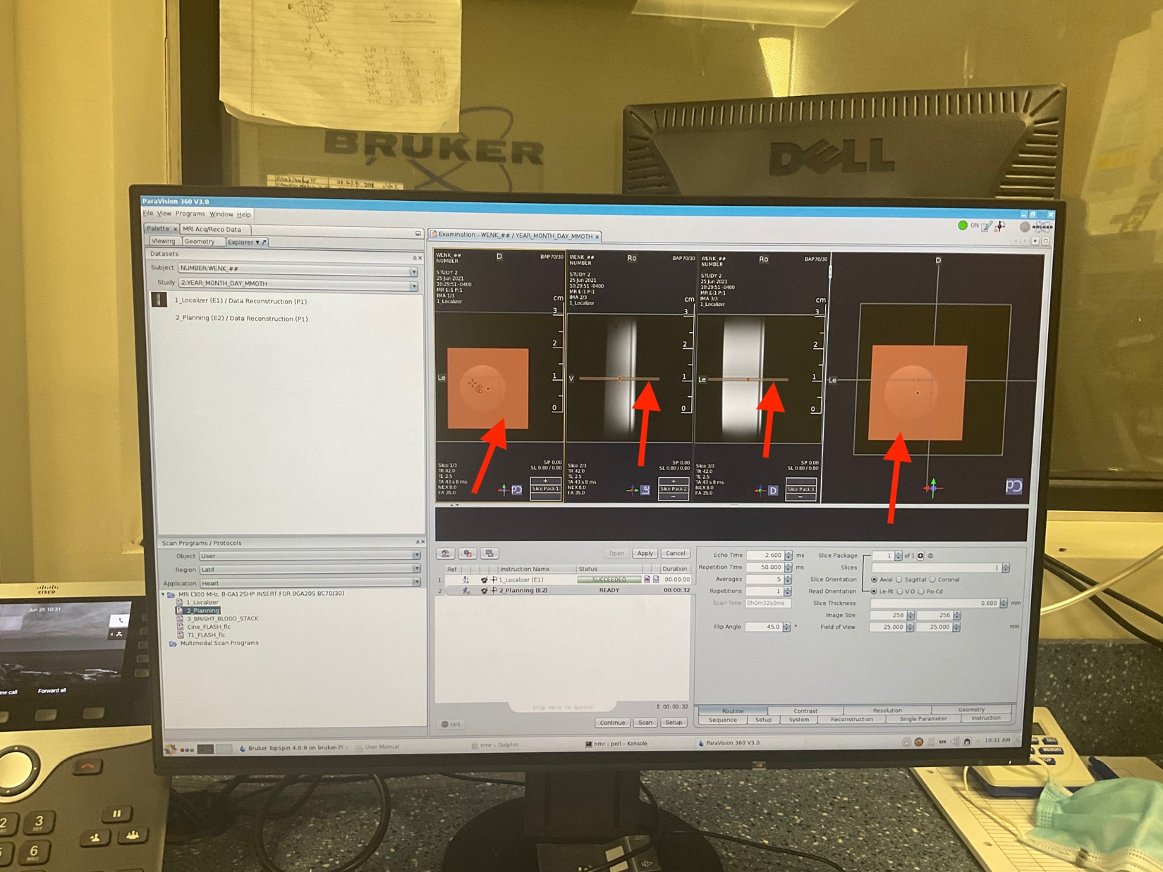

1. Adjust the location of imaging “slice” to be in the center of targeted object/organ (e.g. heart).

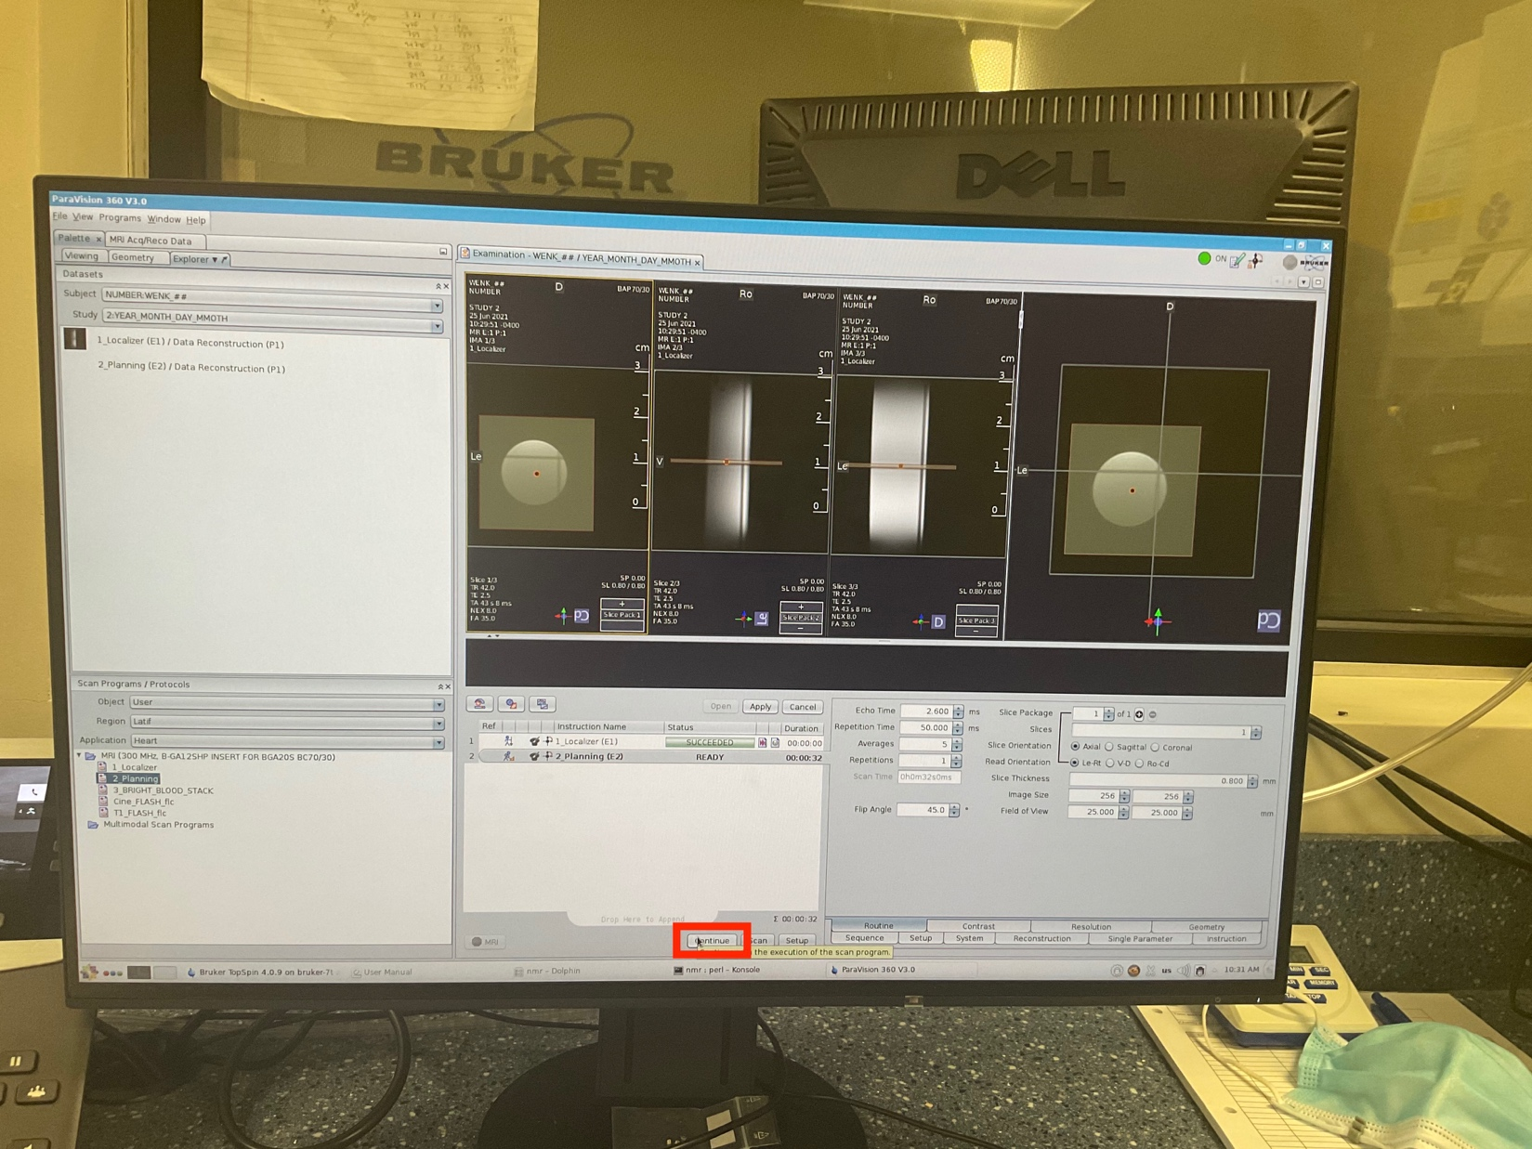

1. Click “continue” to start the scanning.

* To access the “view” tab, the user can do “right_click” on a completed step in the left-top window and select the “view” tab.

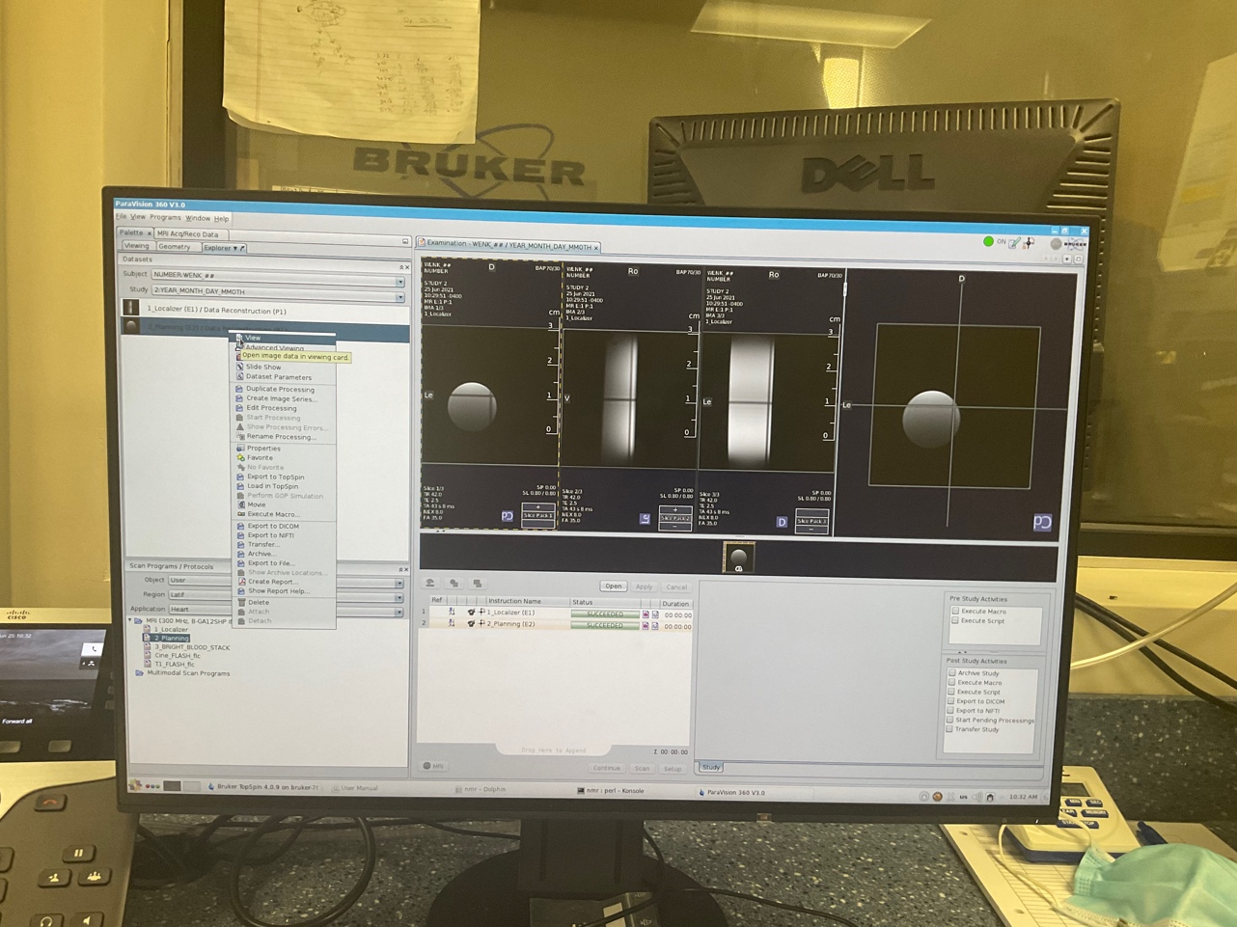

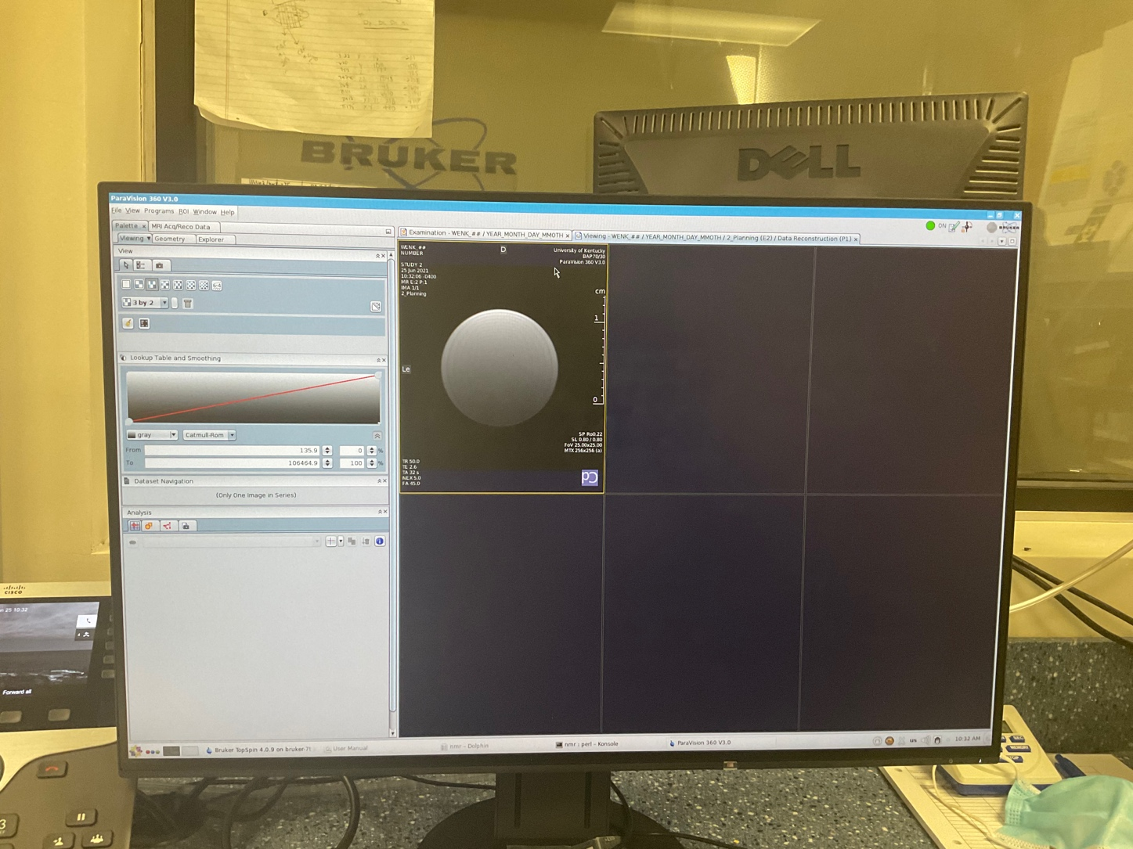

* To access scanned projects and export data:

Window >> “Dataset Browser”

